Medium Term Planning Overview - Ash Class YR and Y1 Summer 2016
Science  This term our science topic is plants. We will be naming and labelling parts of a plant, comparing deciduous and evergreen trees, making birdfeeders and exploring mini beasts.  We will also be looking for signs of spring and summer. | History  We will be comparing Victorian Seaside Holidays and modern seaside holidays. We will also be looking at Punch and Judy and puppets as well as researching Queen Victoria as part of our celebrations for the Queen’s Birthday. | Geography  In geography this term we will be improving our map reading skills and work on recognising map symbols. We will be exploring coastal areas and looking at the natural and manmade features. We will also be discussing where we live in Kimbolton and the surrounding area with the aim of the children being able to explain where they live and their address.
Maths  In maths we will be following the National Curriculum for Year 1 and Development Matters for Reception.  We will continue to improve our knowledge of number, space, shape and measure. This will include addition, subtraction, multiplication, division, 2D and 3D shapes, position and direction, weighing and measuring. | Sun, Sea and Sandcastles  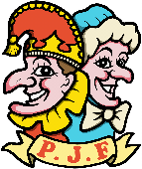  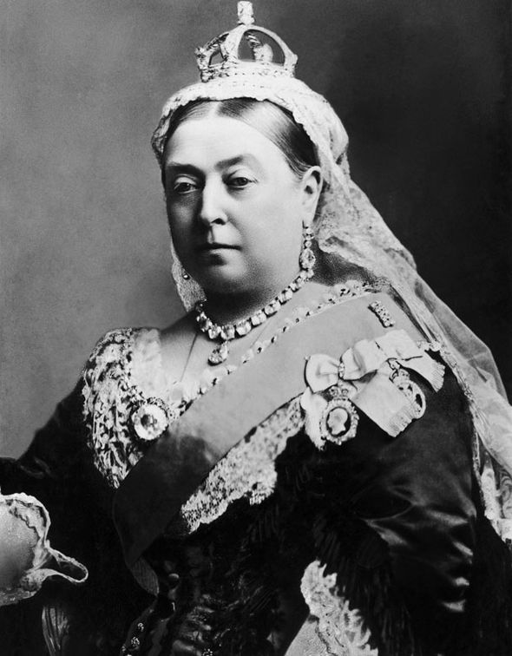  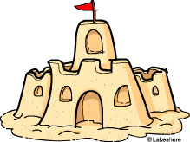 | English  We are focusing on the theme of traditional tales and through this we will build on our spelling, punctuation and grammar skills as well as exploring different types of text. In reception we will continue to build up our fine motor skills, pencil control and letter formation. The children have guided reading sessions every day, as well as 1:1 reading on a weekly basis. They also have phonics sessions every morning in which they learn new sounds and key skills for decoding words.
Music  In music this term we will be using our voices to sing songs, chants and rhymes. We will also explore untuned instruments and listen to and comment on a range of different music. | PSHE  In PSHE we have circle times in which we will be discussing British Values, what makes a good friend and changes. | Art  In art this term we will be doing observational drawings and exploring colour, shape, line and texture. We will also be making clay tiles and imprinting them with seaside objects such as shells, sand and seaweed.
Computing  In computing this term we will be building on our coding skills with the Beebots, as well as practising and discussing esafety. The computers are also available for the children to explore educational games. | RE  In RE we will be exploring special celebrations and events. We will be holding a party for the Queen’s birthday as well as role playing weddings and christenings. | DT  We will be designing and making our own puppets, linking with our Sun, Sea and Sandcastles topic. We will be looking at joining methods and making things move. We will also be making beach huts.
PE: Street Dance; Agility, Balance and Coordination.

