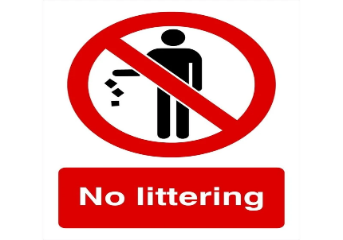
W.C 6th September 2021
Can you write some sentences persuading people not to litter. Don’t forget to write about why littering is bad.

Capital letters &  Full Stops  A • | Connectives   | WOW  words | Careful  spelling  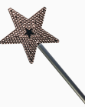 |   Kung fu punctuation | My writing makes sense.

____________________________________________________________________________________________________________________________________________________________________________________________________________________________________________________________________________________________________________________________________________________________________________________________________________________________________________________________________________________________________________________________________________________________________________________________________________________________________________________________________________________________________________________________________________________________________________________________________________________________________________________________________________________________________________________________________________________________________________________________________________________________________________________________________________________________________________________________________________________________________________________

