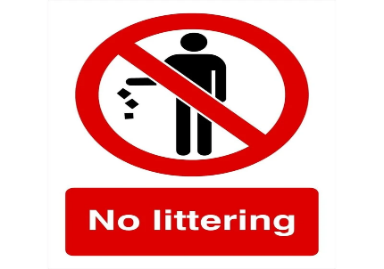
W.C 6th September 2021
Write a piece of persuasive writing about why people should not litter, and what we can do to stop it.

W.C 6th September 2021
Write a piece of persuasive writing about why people should not litter, and what we can do to stop it.

W.C 6th September 2021
Write a piece of persuasive writing about why people should not litter, and what we can do to stop it.

