Recommended Apps for Nursery Pupils
App Name | Logo | Notes
Moose Math | 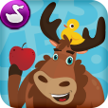 | Free  Parents can monitor child’s progress.  Moose Math | (duckduckmoose.com)
Cbeebies | 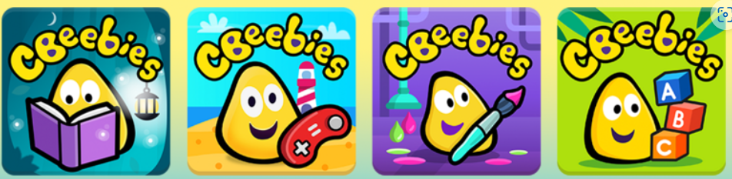 | Free  Lots of different apps for children  CBeebies apps - CBeebies - BBC
Khan Academy Kids |  | Free  Free, fun educational app for young kids | Khan Academy Kids
Scratch Junior |  | Free  Great for learning simple coding!  ScratchJr - Home
Elmo Loves 123s | 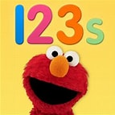 | Free  Parents can monitor child’s progress.  Lots of different apps. See list here: Sesame Street | Preschool Games, Videos, & Coloring Pages to Help Kids Grow Smarter, Stronger & Kinder
Montessorium Intro to Maths | 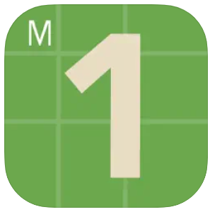
Bedtime Math by Bedtime Math Foundation |  | Daily maths puzzles.  Home - Bedtime Math

