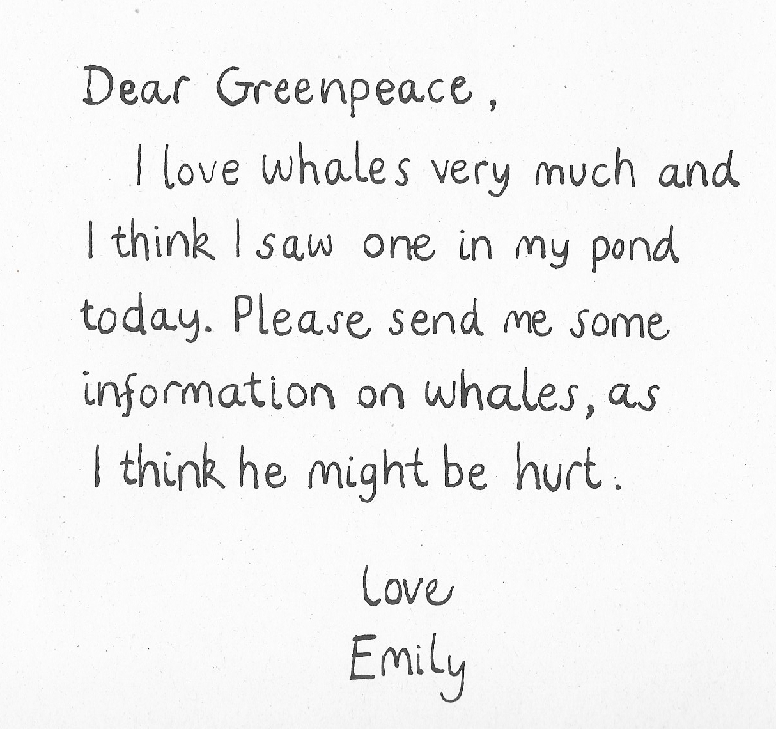

Unit 2: Day 1: Input
Blue Whales

- Cut out the words in each line.
- Notice the punctuation marks.
- Arrange the words into a sentence.

mammal. | The | biggest | blue | the | whale | is
south | migrate | Blue | in | whales | the | winter.
krill. | called | on | They | feed | creatures | tiny
years. | whales | 110 | Blue | can | live | for

Unit 2: Day 1: Easier
Blue Whales

Add a missing capital letter and full stop to each sentence.
the blue whale is the biggest mammal
blue whales migrate south in the winter
they feed on tiny creatures called krill
a blue whale can live for 110 years
a blue whale can grow to 25 metres long
blue whales come to the surface to breathe
Write you own sentence. Remember to begin it with a capital letter and to end it with a full stop.
Unit 2: Day 1: Activity
Blue Whales

- Read each question.
- Orally prepare an answer.
- Write the answer as a correctly punctuated sentence.
What do blue whales look like?
Can a blue whale live in a pond?
What do blue whales eat?
Have you ever seen a real blue whale?
Unit 2: Day 1: Harder
Missing Punctuation Marks

I think I saw a whale in my pond today.
Whales live in salt water.
Last night I saw my whale smile.
Whales don’t get lost.
i saw my whale jump up and spurt lots of water
blue whales eat tiny shrimp-like creatures that live in the sea
whales are too big to live in a garden pond
i saw a whale at the seaside and he let me stroke his head

Unit 2: Day 1: Plenary
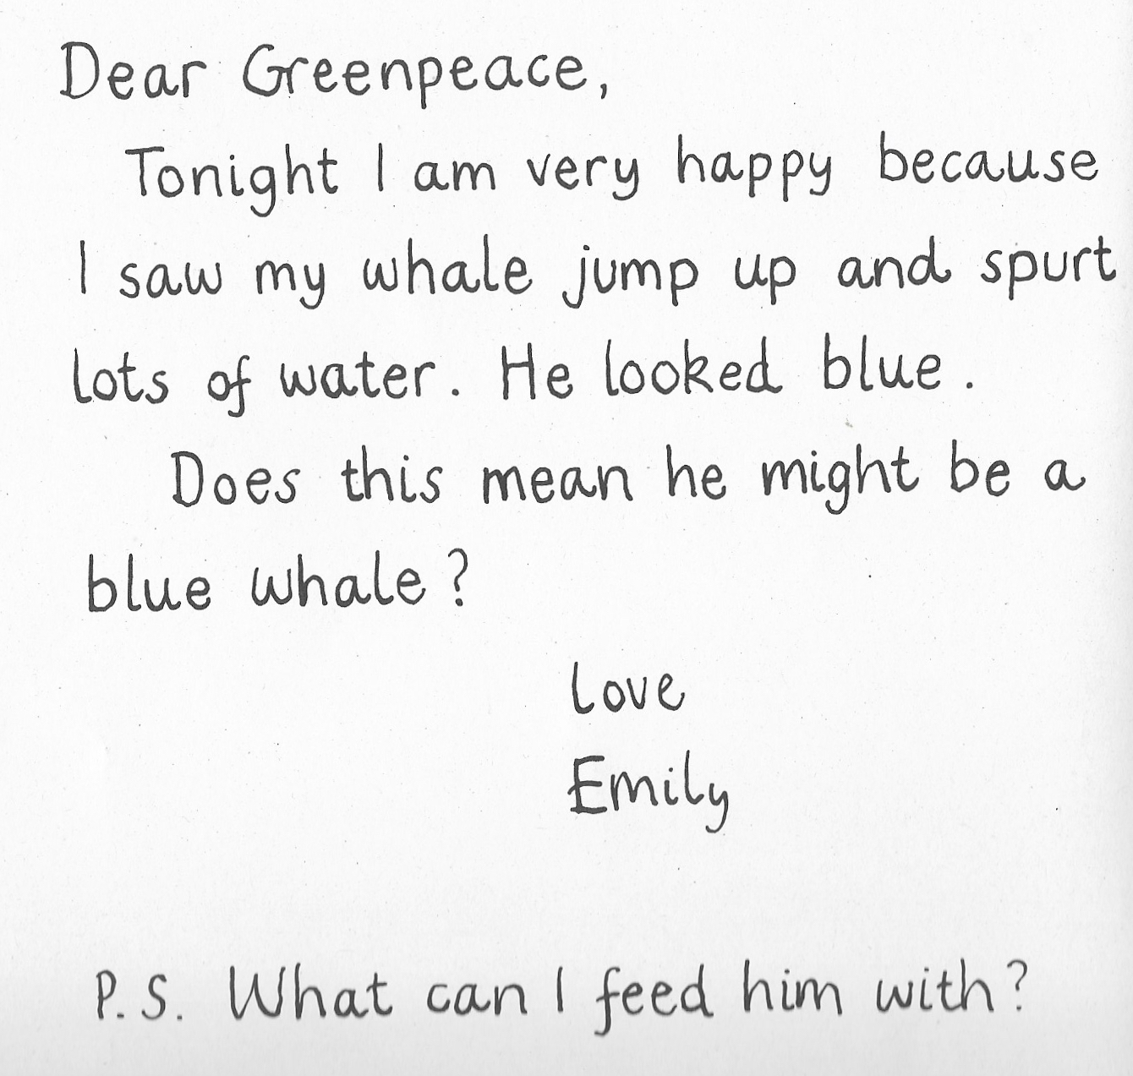
Unit 2: Day 2: Input
Turtles  All turtles have a shell and flippers and come ashore once a year to lay their eggs.  Turtles have a special shell to cover and protect their body. A turtle’s shell is made of hard bony scales.  Many types of turtles can live to be over a hundred years old. | Basking Sharks  Basking sharks can grow to be 12 metres long.  Despite being big they are harmless to humans. Basking sharks eat tiny plankton.  Basking sharks live all over the world and can often be found in the sea around the United Kingdom.

Unit 2: Day 2: Activity
Common Dolphins  Common dolphins live in groups of between 10 and 30. However, they have been known to live in groups of up to 100.  Common dolphins breathe air through special nostrils on the top of their body.  Common dolphins are very fast swimmers. They are carnivores and eat a range of fish and squid.  Common dolphins have few natural predators. Humans are their main threat. | Grey Seals  Grey seals swim in the ocean but they can also move on the land. They have strong flippers to help them move quickly through the water.  Grey seals need to breath air. They can dive deep under the water and hold their breath for about 15 minutes, but they must always come to the surface.  Grey seals eat a wide variety of sea animals. They have sharp teeth to crack shells and break bones. Grey seals use their big eyes and excellent hearing to help catch prey.

Unit 2: Day 2: Activity
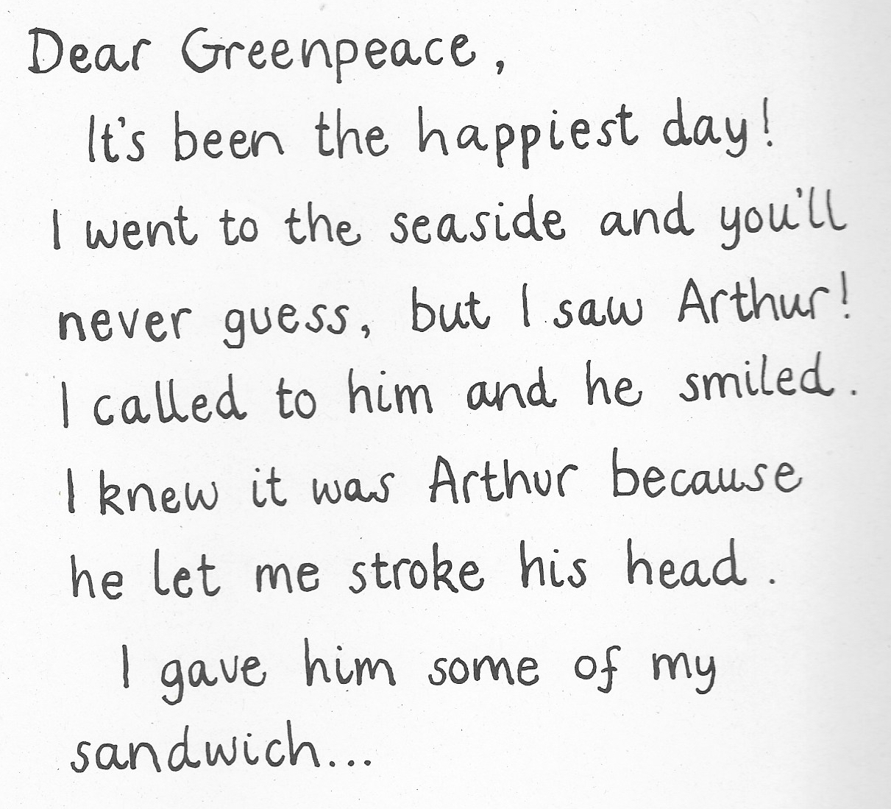
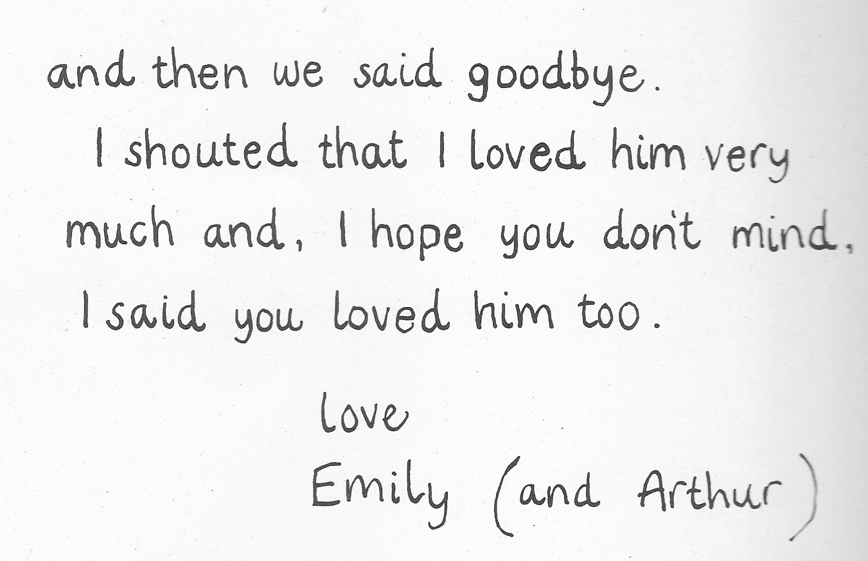
Unit 2: Day 3: Input
Statement, Questions and Exclamations

- Read each sentence.
- Add the final punctuation marks ( . ! ? )
- Read it aloud correctly.
Mum, there is a whale in the pond
What colour is it
It is blue and it is very big
Do you think he is lost
Whales eat tiny shrimp like creatures
Today has been the happiest day
I called to Arthur and he smiled at me
Will I ever see him again
I shouted that I love him
I saw Arthur
Does this mean he is a blue whale
Imagine you are Emily, Arthur or Greenpeace.
What statements, questions and exclamations might they say? Say your idea aloud. Then write each sentence into your book. Remember to use correct punctuation!
Unit 2: Day 3: Activity
Statement, Questions and Exclamations

- Read each sentence.
- Add the final punctuation marks ( . ! ? )
- Read it aloud correctly.
- Cut out the sentences and group them by type.

Mum, there is a whale in the pond
What colour is it
It is blue and it is very big
Do you think he is lost
Whales eat tiny shrimp like creatures
Today has been the happiest day
I called to Arthur and he smiled at me
Will I ever see him again

Unit 2: Day 3: Easier
Dear greenpeace
last night i looked out of my bedroom window and saw a penguin splashing in my pond
What a surprise
Please send me some information about penguins because I would like to know more about them
Do you think he knows Arthur
I have given him a tin of fish to eat
Love emily

Unit 2: Day 4: Input
Dear Greenpeace,

I have seen a penguin in our pond He is black and white with a yellow beak

I have given him some fish to eat I think he liked it

please send me information about penguins

Love Emily

Unit 2 Day 4: Easier
Dear Greenpeace,
I have seen a penguin in our pond
How amazing
He is black and white with a yellow beak
i think he looks beautiful
i have given him some fish to eat
What do penguins eat
I think he liked it
How can i look after him
i hope he is enjoying swimming in our pond
please send me information about penguins
Love emily

Unit 2: Day 4: Activity
Unit 2: Day 4: Extension
A Letter to Greenpeace

