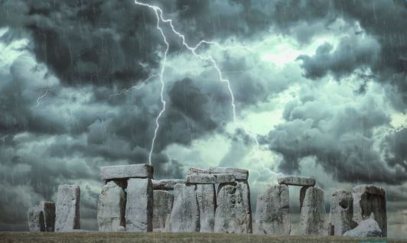
W.C 24th January 2022.
Can you describe this picture? Look at all of the different things you can see. Remember to use as many descriptive words and phrases as possible.
Top tip: Remember to think about your five senses!

Capital letters &  Full Stops  A • | Connectives   | WOW  words | Careful  spelling  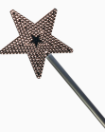 | 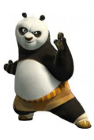  Kung fu punctuation | My writing makes sense.

____________________________________________________________________________________________________________________________________________________________________________________________________________________________________________________________________________________________________________________________________________________________________________________________________________________________________________________________________________________________________________________________________________________________________________________________________________________________________________________________________________________________________________________________________________________________________________________________________________________________________________________________________________________________________________________________________________________________________________________________________________________________________________________________________________________________________________________________________________________________________________________

