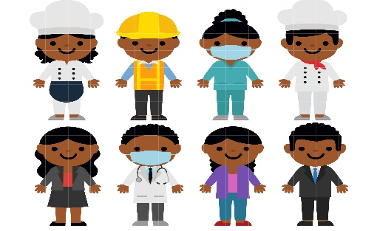
W.C 28th March 2022
Write about your dream job. What is your dream job? Why do you want that job? What does that job involve? What skills do you already have that would be good for that job?

Capital letters &  Full Stops  A • | Connectives   | WOW  words | Careful  spelling  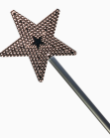 | 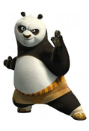  Kung fu punctuation | My writing makes sense.

____________________________________________________________________________________________________________________________________________________________________________________________________________________________________________________________________________________________________________________________________________________________________________________________________________________________________________________________________________________________________________________________________________________________________________________________________________________________________________________________________________________________________________________________________________________________________________________________________________________________________________________________________________________________________________________________________________________________________________________________________________________________________________________________________________________________________________________________________________________________________________________

