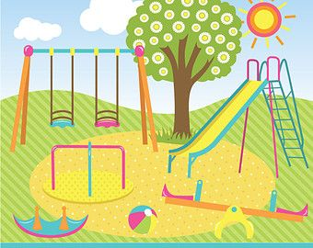
W.C 21st February 2022.
Today you will be writing a recount. You need to write a recount of what you did in your half term.
Remember the key features of a recount!

Capital letters &  Full Stops  A • | Connectives   | WOW  words | Careful  spelling  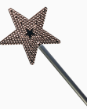 | 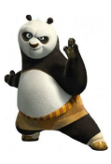  Kung fu punctuation | My writing makes sense.

____________________________________________________________________________________________________________________________________________________________________________________________________________________________________________________________________________________________________________________________________________________________________________________________________________________________________________________________________________________________________________________________________________________________________________________________________________________________________________________________________________________________________________________________________________________________________________________________________________________________________________________________________________________________________________________________________________________________________________________________________________________________________________________________________________________________________________________________________________________________________________________

