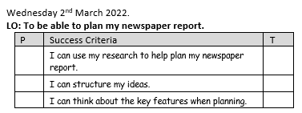

Skara Brae Newspaper Article
Headline:
_____________________________________________________________
Who was involved:
_____________________________________________________________
What happened:
_______________________________________________________________________________________________________________________________________________________________________________________
When did this happen:
_____________________________________________________________
Where did this happen:
_____________________________________________________________
Why did it happen:
__________________________________________________________________________________________________________________________
Did anyone at the event say anything to the newspaper reporter (quotes) :
_______________________________________________________________________________________________________________________________________________________________________________________

