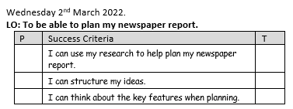

Skara Brae Newspaper Article
Headline (title of the article):
_____________________________________________________________
Who are the people involved:
_____________________________________________________________
What key events happened:
_______________________________________________________________________________________________________________________________________________________________________________________
When did this happen:
_____________________________________________________________
Where did this happen:
_____________________________________________________________
Why did it happen (you might not know):
__________________________________________________________________________________________________________________________
Did anyone at the event say anything to the newspaper reporter (quotes) :
_______________________________________________________________________________________________________________________________________________________________________________________

