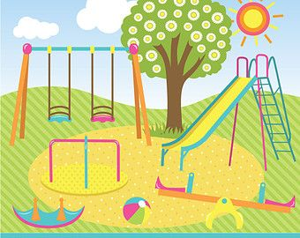
W.C 21st February 2022.
Today you will be writing a recount. You need to write a recount of what you did in your half term.
Remember the key features of a recount!

W.C 21st February 2022.
Today you will be writing a recount. You need to write a recount of what you did in your half term.
Remember the key features of a recount!

W.C 21st February 2022.
Today you will be writing a recount. You need to write a recount of what you did in your half term.
Remember the key features of a recount!

