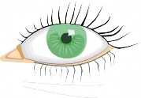 |  | 
Look | Cover | Write | Check
Unit 19 Year 4 This unit focuses on words ending with –f, -ff, -fe and -ves.

Spelling | 1st Attempt | 2nd Attempt | 3rd Attempt
calf
calves
half
halves
loaf
loaves
shelf
shelves
cliff
cliffs
puffs
knife
knives
self
selves
wife
wives
cuff
cuffs
sniff
sniffs

