OAK CLASS
INDIAN COMPOSER – RAVI SHANKAR
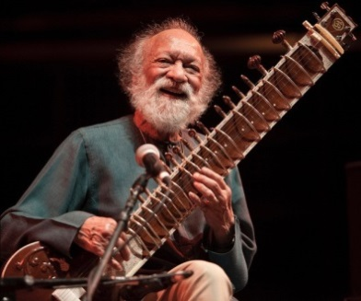
Ravi Shankar - 1920-2012
Indian composer, brought Indian classical music to the west in 1960’s. He was huge influence on George Harrison (Beatles) and Yehudi Menuhin (violinist).
The piece of music we are looking at this half term is Shankar’s Symphony – finale , composed in 2010. It is a cross between a symphony and concerto. The solo instrument , called a sitar, is mainly improvised (made up as the player goes along) and uses traditional Indian ragas instead of major/minor keys. The vocal section by orchestra uses Indian drum syllables. Shankar’s style was to compose Hindustani music for use by western orchestras. You can see a performance and more information of this here:
https://www.bbc.co.uk/teach/ten-pieces/classical-music-ks2-ravi-shankar-symphony-finale/zdj28xs

- While you are listening to the performance piece, complete the appreciation sheet on the next page. You can either print it or use the prompts to help you.
- A sitar is a traditional Indian musical instrument. Can you find out 3 facts about it, draw a picture and label it?
- Year 3 - Can you find out about any other Indian musical instruments and identify which family they belong to e.g. strings, percussion, brass, woodwind?
