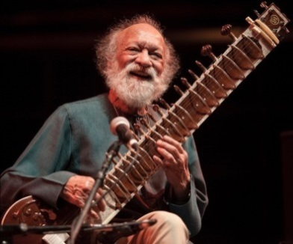
Oak Class
Home Learning Week 2
Indian Composer – Ravi Shankar

This week we are going to learn about drones and ragas.
Watch the video from last week :
https://www.bbc.co.uk/teach/ten-pieces/classical-music-ks2-ravi-shankar-symphony-finale/zdj28xs
A drone is a long note played underline the melody (tune) in a piece of music. The drone is played almost all of the way through the music. Can you hear it?
Sitting comfortably on the floor or a chair, tap your knees so that it makes a low rumble sound. You may need to tap quite quickly to get the sound. Which part of you makes the lowest sound? When you can make a low rumble sound on your knees, try and hum in a low pitch too at the same time. If you have members of your family with you, they could join in too. Maybe you could do this while listening to Symphony.
A raga is a scale used in Indian music. The notes of the raga give Shankar’s symphony its special unique sound.
If you have an instrument at home, find these notes: A, E, F#, G, A Bb, C, D. If you don’t have an instrument at home there are plenty of free xylophones on line. You could also use Garageband (Apple devices) or CromeLab (android) instruments. The solo instrument in the video is called a Sitar and the player often improvises (makes up on the spot), playing whatever they like as long as they stick to the raga. You can play a melody on your instruments only using these notes and hum a low pitch drone at the same time. (You can just use D, E, F#, G).
LO: I can make a low rumble drone tapping my knees and using my voice
I should use an online xylophone or app to play my composition
Even better if I can use an on line app to record my composition.

I would really like to see your work if you could mail it into the office.
Well done everyone.

