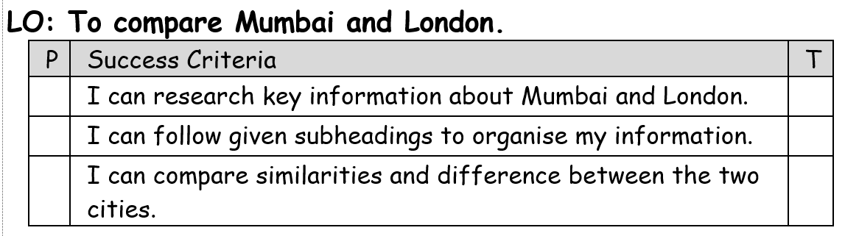

Homework:
This term in topic, we are looking at the India.
For homework (flip learning task), children are asked find out more information about the financial, commercial and entertainment capital of India, Mumbai.
Children can present their information however they like however it must clearly show information and compare the work of both people. If children choose to present using PowerPoint, they must subheadings on each slide to clearly organise their research (7 slides maximum). Children can use pictures as examples but their focus should be on the writing. They should also write some notes in their homework books to help them present their information to the class without reading straight from the slides. If you are unable to access PowerPoint at home, you can present your information as paragraphs in your homework book or as a double page spread.
Children must find out information about Mumbai and London before comparing the two. Children may choose to do this with a side by side comparison of each subheading.
Some suggested information might include:
- Population (how many people live there)
- Links to the rest of the country (transport)
- Geographical location within the country
- What life is like (Culture)
- Weather conditions
- Landmarks (famous buildings/statues)

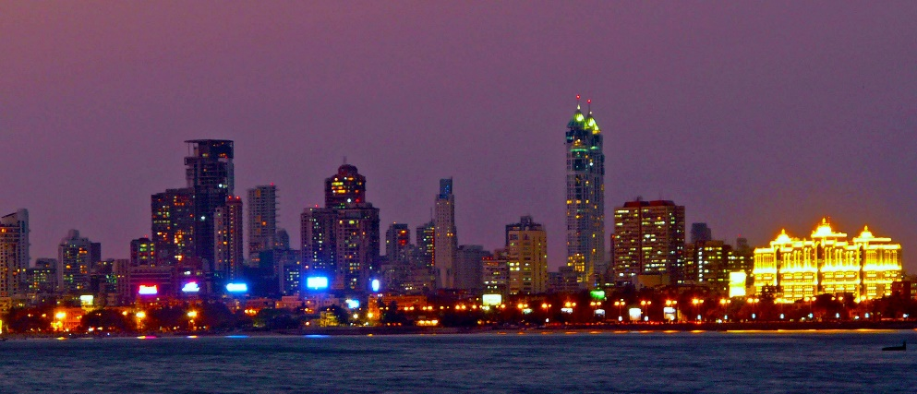
Homework due: Thursday 21st March

