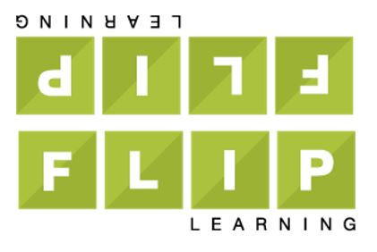
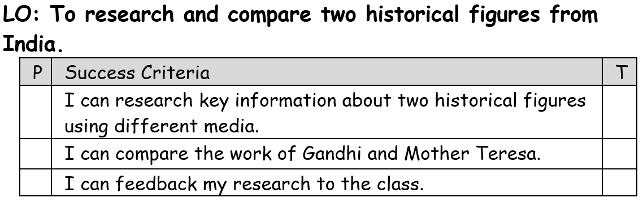
Homework: Thursday 11th January 2024
This term in topic, we are looking at the India.
For homework (flip learning task), children are asked find out more information about two famous figures in Indian history, Gandhi and Mother Teresa.
Children can present their information however they like however it must clearly show information and compare the work of both people. If children choose to present using PowerPoint, they must subheadings on each slide to clearly organise their research (7 slides maximum). Children can use pictures as examples but their focus should be on the writing. They should also write some notes in their homework books to help them present their information to the class without reading straight from the slides. If you are unable to access PowerPoint at home, you can present your information as paragraphs in your homework book or as a double page spread.
Children must find out information about Gandhi and Mother Teresa before comparing their work/what they are famous for.
Some suggested information might include:
- Where and when they were born
- Their family life/upbringing
- What they are famous for/what work they did
- Any awards or recognition
- What they have in common/what is different about them
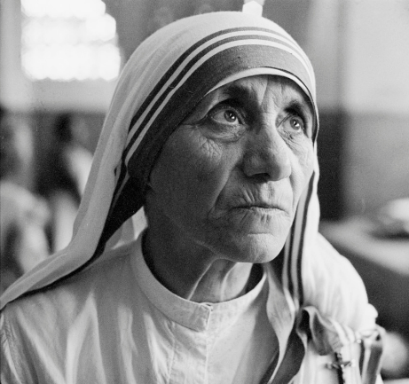
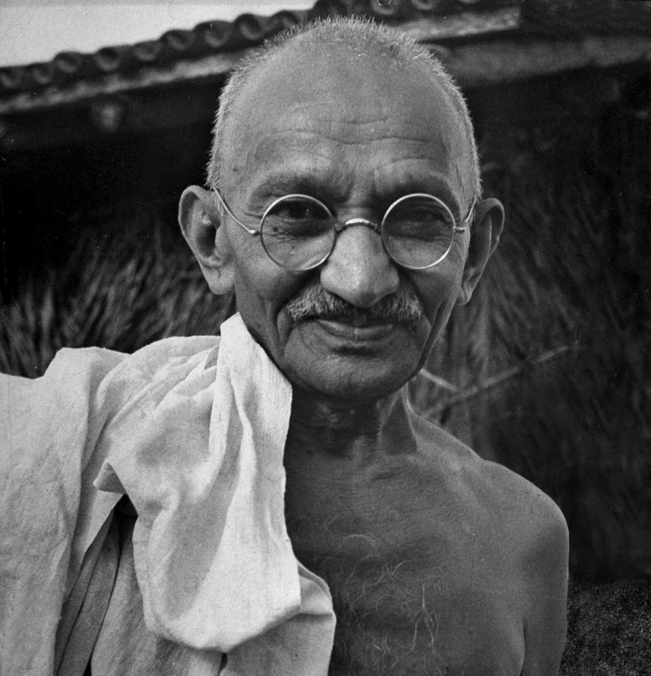
Homework due: 23rd January

