Home learning due Tuesday 9th November 2021
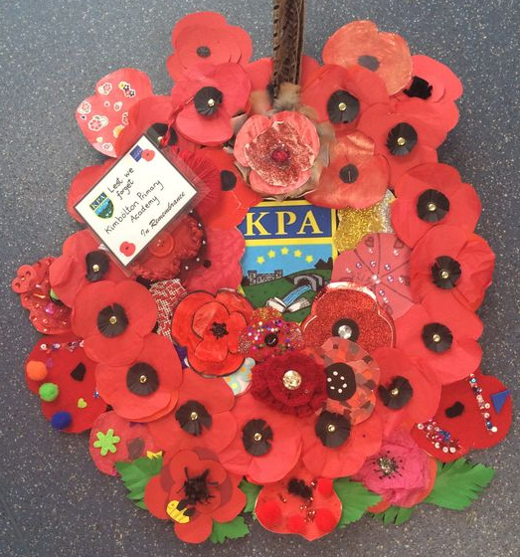
The symbol of remembrance in the UK is a poppy; a small red flower.
This is because many poppies grew on the battlefields of WW1 after the fighting ended.
Carefully read ‘In Flanders Fields’ by John McCrae. He was a soldier who fought in WW1 and this is one of the conflict’s most famous poems.
Then answer the questions below.
‘In Flanders fields, the poppies blow’.
‘Between the crosses, row on row, that mark our place.’
- What do ‘the crosses’ signify?
- What does the phrase ‘row on row’ suggest to you?
‘and in the sky
The larks, still bravely singing, fly
Scarce heard amid the guns below’.
- What is a lark? Why do you think the poet has mentioned them, and what might they be a symbol of?
- Look at the beginning of the second stanza. Who is the point of view of the poem from?
- In the last stanza, what does the narrator of the poem want the reader to do?
- Do you agree with them, that this is the right thing to do? Or do you disagree? Why do you think so?
- Overall, how would you describe the mood of this poem?
Optional Task
Read some other poems by war poets such as Wilfred Owen or Siegfried Sassoon. Which one was your favorite? Explain why.

