
Homework: Stonehenge
Thursday 6th February
This term in topic, we are looking at the Stone Age to Iron Age.
For homework (flip learning task), children are asked to find out more about Stonehenge which we will look at as part of our learning later in the unit.
Using the Stonehenge fact sheet provided and/or by completing their own research, children must create a fact file in their books about the monument. Children must write in paragraphs using subheadings to organise their information. A minimum of one side of A4 is required.
An example of layout is shown below:
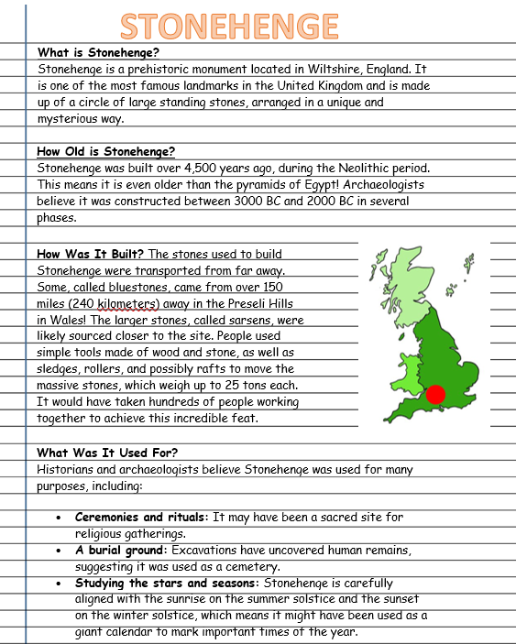
Information to include:
- Where it is located and when it was created
- What it was used for
- How historians think it may have been made
- Any other interesting facts

Homework due: 25th February

