LO: To research and present information about Victorian life.
P | Success Criteria | T
 | I can research similarities and differences between rich and poor Victorians.
 | I can present my information cohesively using a PowerPoint.
 | I can present my findings to the class using notes.
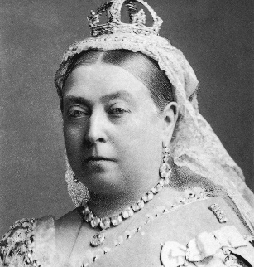
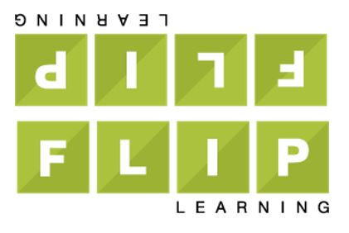
Homework: Thursday 21st September
This term in topic, we are looking at the The Victorians.
For homework (flip learning task), children are asked find out more information about Victorian life with a focus on the differences between rich and poor Victorians.
Children must present their work as a PowerPoint using subheadings on each slide to clearly organise their research (7 slides maximum). Children can use pictures as examples but their focus should be on the writing. They should also write some notes in their homework books to help them present their information to the class without reading straight from the slides. If you are unable to access PowerPoint at home, please let your class teacher know so that they can arrange laptop access at break/lunch times.
Children must compare the differences between rich and poor Victorians clearly for each area.
Some suggested slides might include:
- School for rich and poor
- Working and living conditions (houses, servants etc.)
- Clothing for rich and poor
- Food for rich and poor

Homework due: Tuesday 10th October

