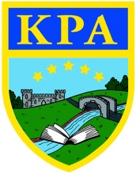
Puddleducks Home Learning Rainbow Challenge
Communication and Language  I spy.  Play a game of I spy with your child.  Depending on their abilities, you can make the clues quite simple or harder!  For younger children it could be, “I spy something stripy”  For older children it could be, “I spy something with 4 corners”  Aim – Develop listening skills, notice details in the environment. | 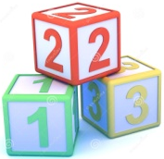  W/c 11th Jan 2021  This week to help you keep up the  amazing learning I have seen already,  I have made the children a rainbow  challenge for the week! Here are 7 challenges for you to have ago at. When you complete a challenge either put it onto tapestry or email me and when you have completed any of them!  Good luck and keep up the super learning! | Physical Development  Marking with different tools.  Put a shallow layer of either sand, flour, rice into a shallow tray. Encourage your child to use different tools to make marks in the tray.  You can use brushes, sticks, their finger, anything you can find!  Can they mark a circle?  A letter from their name?  Aim – Develop fine motor skills.
 | Understanding the World  RSPB Challenge –  Make a bird feeder for your garden.  You can use bird seed, cheese, rasins, breakfast cereal such as oats for this.  You could poke sunflower seeds into an apple, poke in a stick for the birds to stand on and hang it up and watch for the birds to come!  There are also more ideas on the RSPB website! | Expressive arts and design  Build with bricks.  These can be duplo, lego, wooden blocks, cereal boxes, whatever you have about.  Talk about what they are building, talk about the position on the blocks – on top, next to, behind, under for example.  Don’t forget to take a photo or video for Tapestry!
Personal, social and emotional
Talk to your child about what make you the same and what makes you different.
For example:
You both have 2 eyes, but they may be different colours.

Aim – Notice the differences and similarities in ourselves and others.

Mathematics
Order objects by height.
For older children use 3 objects and talk about which is the smallest/biggest, ask your child if they can put them in order from with the smallest first. Can they find there own objects to order?
For younger children use 2 objects, can they point to the big one? The small one?
Can they find a small/big toy in their toy box?
Aim – Develop an understanding of size.

Literacy
Read a story with your child. Talk to your child about the pictures, can the name the characters? Can they point to objects? What do they think might happen next? Did they like the story? Why?
Aim – Listen to stories with increasing attention and recall, talk about characters and illustrations. Develop an enjoyment of books and pictures.

