04.10.21
LO: To add and subtract numbers up to 20.
P | I can | CT
 | I can recognize and use the addition and subtraction symbols correctly.
 | I understand how to use parts and whole numbers.
 | I can use my knowledge to make fact families up to 10/20.
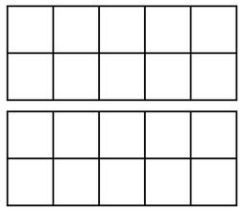
Use two different colours to fill in the 20s frame. Can you create a fact family for each number bond to 20 that you create?
Remember that when we add, the biggest number goes after the equals sign (=).
When we subtract, we start with the biggest number first.

______ + ______ = ______
______ + ______ = ______
______ - ______ = ______
______ - ______ = ______
______ + ______ = ______
______ + ______ = ______
______ - ______ = ______
______ - ______ = ______
______ + ______ = ______
______ + ______ = ______
______ - ______ = ______
______ - ______ = ______
______ + ______ = ______
______ + ______ = ______
______ - ______ = ______
______ - ______ = ______
______ + ______ = ______
______ + ______ = ______
______ - ______ = ______
______ - ______ = ______
______ + ______ = ______
______ + ______ = ______
______ - ______ = ______
______ - ______ = ______
______ + ______ = ______
______ + ______ = ______
______ - ______ = ______
______ - ______ = ______

