Q1. 62 - 9 =
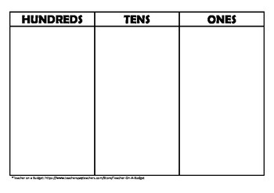

Q2. 71- 8

Q3. 28 – 9

Q4. 42 – 7 =

Q5. 24 – 9 =

