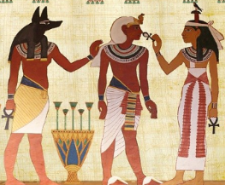

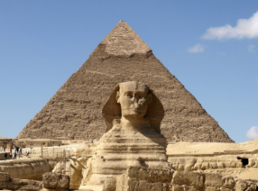
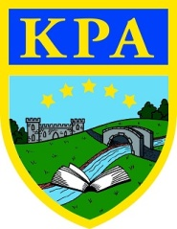
Ancient Egyptians
Knowledge organiser:

Summer term 2020
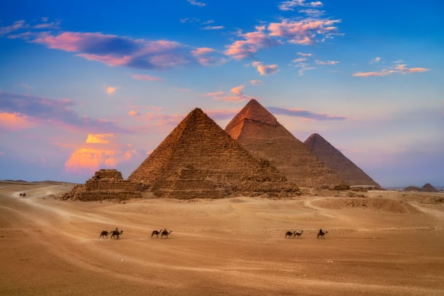
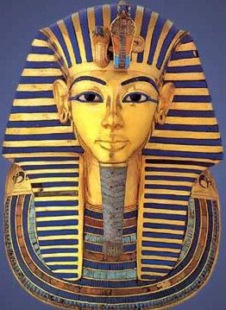
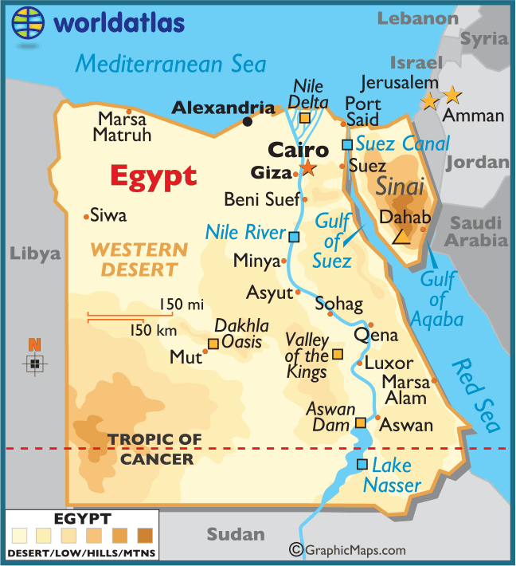
Learning Journey — Ancient Egypt was one of the greatest and most powerful civilizations in the history of the world.
To begin this topic it would be great to introduce to children where Egypt is on a map to help them understand which continent it is in (Africa). Then, discuss with them what the word ‘ancient’ means as this will provide context to this topic. Explain that this powerful civilization lasted for over 3000 years from 3150 BC to 30 BC. This BC means Before Christ so this happened over 3000 years before the birth of Jesus Christ.
The Ancient Egyptians are very famous for building the pyramids, amazing structures created as tombs for the rich and powerful. Incredibly, they have remained standing for thousands of years and can still be visited today! People in Ancient Egypt believed in the afterlife and practised Mummification, a process that preserved the body of the deceased. Tombs were also given lavish decoration and filled with precious and useful objects for the afterlife. Archaeologists (people who study very old objects to learn about the past) have discovered lots about life in Ancient Egypt after digging up tombs like this.
People in Ancient Egypt were ruled by powerful leaders known as Pharaohs and believed in lots of different gods and goddesses, including some that were seen as half-animal, half-human. They wrote using hieroglyphics, and produced some of the world’s first examples of mathematical writing.

Need to know | Nice to know | Super specialist
river | nation | sarcophagus
country | climate | canopic
continent | Pharaoh | embalm
Egypt | Egyptian | cartouche
ancient | afterlife | sphinx
civilisation | slave | scarab beetle
Nile | tomb | amulet
people | hieroglyphics | Tutankhamun
god | papyrus | Cleopatra
goddess | mummification | dynasty
king | Cairo | Giza
pyramid | Africa | Ra
mummy | desert | Horus
Key dates:
7,500 BC – the first settlers arrive in the Nile Valley
3,200 BC – Hieroglyphs are first used
2,640 BC – the first pyramid is built
2,555 BC – the Giza pyramids are built
2,520 BC – the Great Sphinx is built
2,200 BC – the first ploughs are used by farmers in Egypt
1,332 BC – the reign of King Tutankhamun begins
51 BC – the reign of Cleopatra begins and the Egyptian civilisation ends

Links to future learning:
• India (next year)
• RE topics: Christianity, Judaism, Islam
• Ancient Civilisations – Maya, Ancient Greeks (Upper KS2)

Books to read:
Flat Stanley - The Great Egyptian Grave Robbery by Jeff Brown
Ancient Egypt: Tales of Gods and Pharaohs by Marcia Williams
(Usborne) See inside Ancient Egypt by Rob Lloyd Jones
The Egyptian Cinderella by Shirley Climo. This text is also available read aloud at https://www.youtube.com/watch?v=dSVfIc4l8Lk
Fun facts for you all about ancient Egypt!
• Egyptian men and women wore makeup. It was thought to have healing powers, plus it helped protect their skin from the sun.
• They used mouldy bread to help with infections.
• They were one of the first civilizations to invent writing. They also used ink to write and paper called papyrus.
• The Ancient Egyptians were scientists and mathematicians. They had numerous inventions including ways to build buildings, medicine, cosmetics, the calendar, the plough for farming, musical instruments, and even toothpaste.
• The Pharaoh kept his hair covered. It was not to be seen by regular people.
• Cats were considered sacred in Ancient Egypt.

Web links:
National Geographic website for kids:
https://www.natgeokids.com/uk/
A great, age appropriate source of information -
https://www.ducksters.com/history/ancient_egypt.php

Links to past learning:
• European countries – map making
• Everyday life (Tudor times)
• Different belief systems – Anglo Saxons, Romans
• Ancient Civilisations – Romans
• Home and Away topic (Asia)

