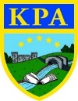

India

Fun facts:
- India is the seventh largest country in the world
- By 2030 India is expected to overtake China as the country with the highest population
- People in India greet each other by saying ‘Namaste’ (pronounced na-ma-stay) which means ‘I bow my head to you’.
- Cows are considered sacred in India, and must not be harmed. They are allowed to go where they want, and may even cause traffic jams when they walk through cities!
- India is the seventh largest country in the world.
- By 2030 India is expected to overtake China as the country with the highest population.
- The national bird of India is the peacock.
- There are 22 official languages in India.
- The longest river in India is the Ganges.
- India grows more than 40% of the world’s mangoes.
- Where most countries have four seasons, India has six – spring, summer, monsoon, autumn, winter and prevernal.
- Indians are the world’s greatest record breakers one Indian man claims he has not eaten or drunk for 70 years.
- The Taj Mahal, found in the Indian state of Uttar Pradesh, is one of the Seven Wonders of the Modern World.
- The game of chess was invented in India.

.
Learning Journey — During this topic, we will be exploring India with a geographical focus. We will use map skills to locate India on a globe before zooming in to look at key cities and comparing these to London. We will discuss geographical features such as the River Ganges and its significance to Hindu people as a place of pilgrimage. We will be making our own savoury dishes based on the flavours of Indian food in DT and will learn to write numbers in Hindi as part of our language lessons. We will listen and respond to a piece of music by Ravi Shankar before composing our own as an ensemble. Our historical links will be to Mother Teresa and Gandhi whom the children will complete independent research about. We will also use Blooket to consolidate our general knowledge of India.

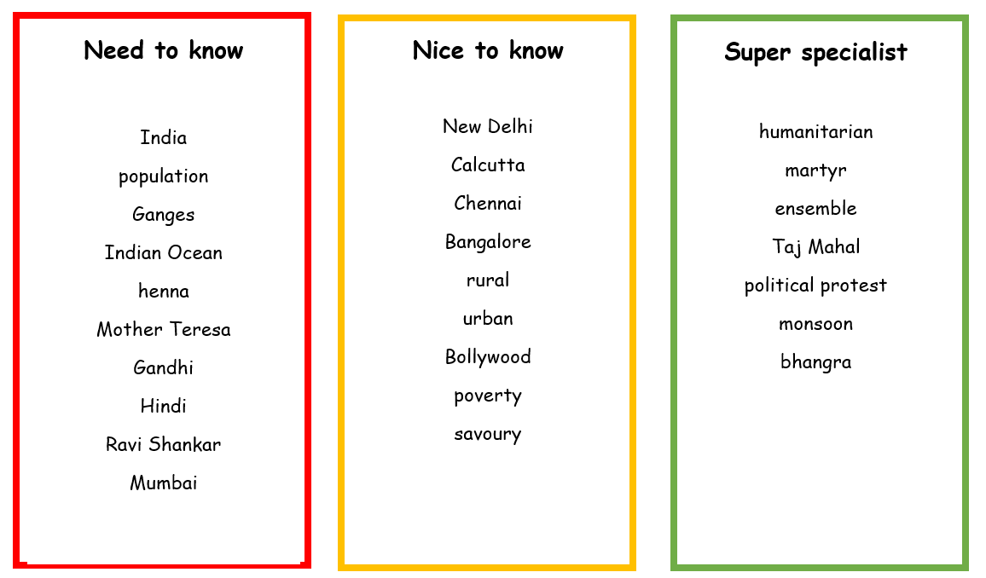
Links to Prior Learning | Key Texts and Websites | Links to Future Learning
- Comparison skills  - Research skills  - Map skills  - Rivers | - India For Kids: Amazing Facts About India (Shalu Sharma)  - Grandma and the Great Gourd (Chitra Banerjee Divakaruni and Susy Pilgrim Waters)  - Grandpa Chatterji (Jamila Gavin)  - Grandpa’s Indian Summer (Jamila Gavin) | - Origins of sport  - Comparison skills  - Geographical skills  - Independent research
Family Fun
- Design and create your own Henna Design.
- Design and create your own Kite for the Annual Kite Festival.
- The Elephant festival is celebrated every year. Can you create and decorate your own elephant?
- Explore different Rangoli patterns. Can you design and create your own?
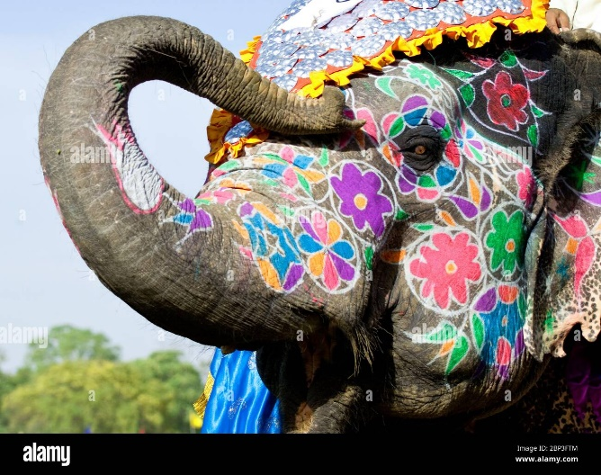
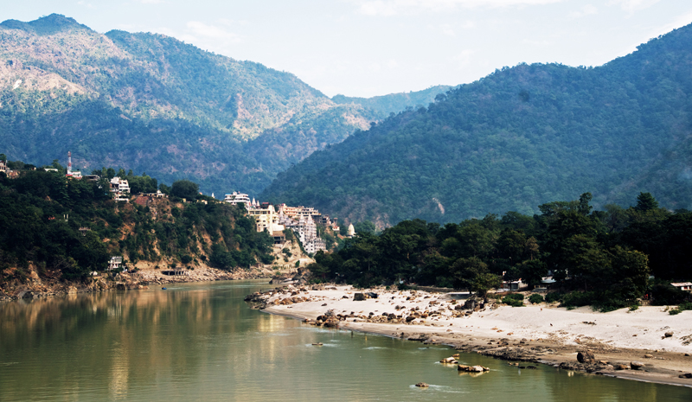
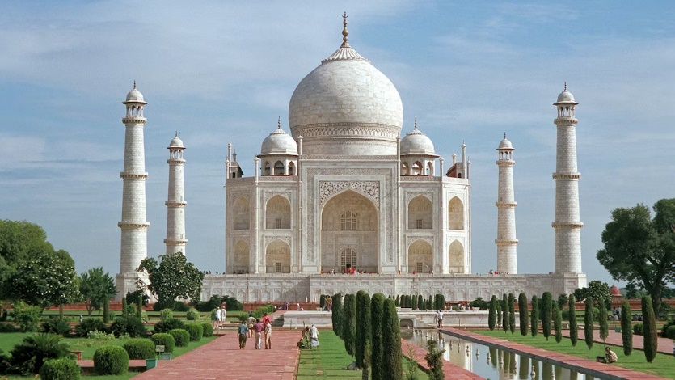
- Can you make your own Diva lamp using salt dough?

