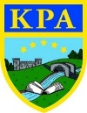

Rainforests

Fun facts:
- The canopy in the Amazon Rainforest is so thick that when it rains, it takes around 10 minutes for the water to reach the ground.
- The UK and Ireland would fit into the Amazon Rainforest 17 times!
- The Amazon Rainforest has an incredibly rich ecosystem – there are around 40,000 plant species, 1,300 bird species, 3,000 types of fish, 430 mammals and 2.5 million different insects.
- Tropical rainforests cover 6-7% of the Earth’s surface but contain over half of all the plant and animal species in the world.
- On average, 137 species become extinct every day as a result of loss of habitat.
- 25% of ingredients in our medicine are from rainforest plants.
- More than 20% of the world’s oxygen is produced in the Amazon Rainforest.
- Rainforests provide people with many cooking spices such as vanilla, black pepper and allspice.

Rainforests get at least 250cm of rain a year. Sometimes it’s almost double that at 450cm.
Learning Journey — During this topic, we will be exploring the different layers of the rainforests and looking in more detail at both the flora and fauna that co-exist in this habitat. The children will look closer at the issue of deforestation and how this is impacting the rainforests. Using the story of Greta and the Giants, children will start to think about how they can be part of a wider change through activism like Greta. We will develop our knowledge of geographical location further as we look at the equator and the Tropics of Cancer and Capricorn. Children will also develop their understanding of the wider world in this topic as they compare the lives of native tribes to their own.

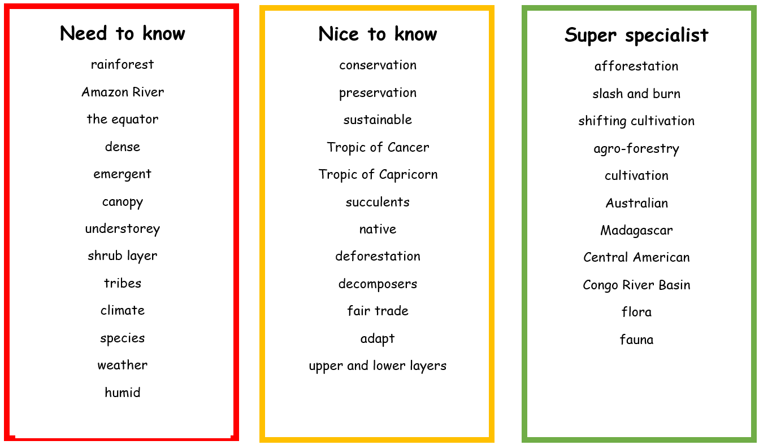

Links to Prior Learning | Key Texts | Links to Future Learning
- Parts of a river  - Geographical knowledge of a map  - Categorisation of animals  - Habitats  - Comparison skills | - Greta and the Giants – Zoe Tucker  - The Explorer – Katherine Rundell  - Journey to the River Sea – Eva Ibbotson  - The Secret Explorers and the Rainforest Rangers – SJ King  - Where the Forest Meets the Sea- Jeannie Baker | - Similarities and differences through human and physical geography.  - To describe and understand key aspects of physical geography, including climate zones.  - Link to the water cycle
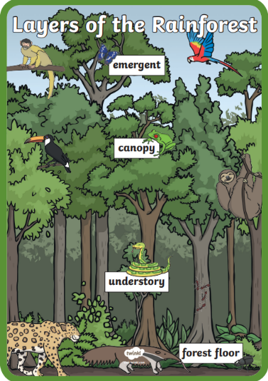
Family Fun

- Design your very own rainforest animal and draw it. Think about: where in the rainforest your animal will live; what it will eat; what colours it will be; how it will move and whether it has any predators.
- Why don’t you try to create a rainforest in a jar using the instructions provided.You will need a clear jar to see this best.
- Read the e-book 'Rainforest Calling'.
- Watch BBC iPlayer - Planet Earth - 8. Jungles with David Attenborough to find out more about this habitat.
- Pay a visit to the Cambridge Botanical Gardens and visit their tropical rainforest room.

