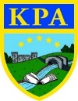

Sports through time

Interesting facts:
- All athletes at the ancient Olympic games competed naked!
- Only free men were allowed to take part in the ancient Olympics; women couldn’t take part or even watch the games.
- There is roughly 200 sports that has international recognition through an international governing body of some sort, also a small part of the estimated 8000 sports played world wide.
- Gold medals were only made of pure gold up to 1912. These days, they are made of silver and have a gold plating.
- In 1908 the Olympics ran for 187 days.
- The race track was 192m long because they thought Hercules could run this far without taking a breath!
- Football wasn’t always as popular as it is today. At the beginning of the 20th century, cricket was the most popular sport! However, this changed during World War I because many soldiers had played lots of football whilst away in different places.
- The Olympic flags rings represent the 5 continents of the world. The colours were chosen because they all appear on the flags of all the competing nations around the world.
- A cricket bat is made of willow wood. This is commonly found in the Northern hemisphere during extreme cold seasons.

.
Learning Journey — During this topic, we will be exploring sports and the Olympics with a historical focus. Children will complete an independent project focused on a sport of their choice and how it has changed over time. We will find about the host countries of the Olympics and what it takes to win a bid. In DT we will be using code and microbits to make a pedometer, which can then be used in our sporting events within our PE lessons. We will listen and respond to a variety of national anthems and perform these. We will also use Blooket to consolidate our general knowledge of Sports through time.

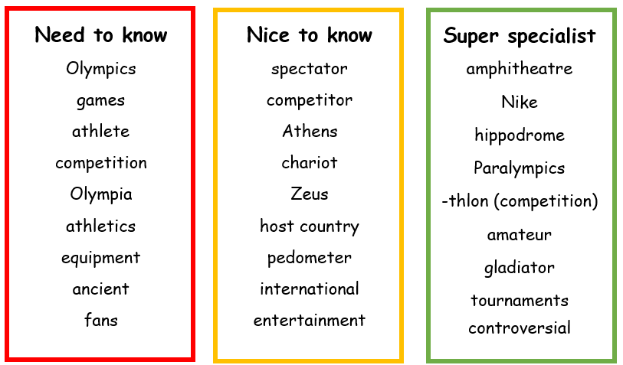
Links to Prior Learning | Key Texts and Websites | Links to Future Learning
- Comparison skills  - Victorian Era  - Research skills  - Chronological skills | - Sports beginnings- Mike Dobbie  - Ancient games: A history of sports and gaming- Flying eye books  - https://olympics.com/en/  - Sportopedia- Adam Skinner | - Comparison skills  - Geographical skills  - Independent research  - Using secondary sources  - Romans

Family Fun

- Could you organise your own Olympics event?
- Design your own medal.
- Make your own Olympic torch!
- Could you visit a stadium nearby?
- Invite a friend to play your favourite sports.
