
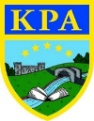
The Vikings!

Learning Journey — We will be exploring The Vikings and their invasion of Britain.
We will look at what Viking warriors were really like and discover what it would have been like to live in those times. We will examine the types of homes people used to live in, what they ate and how they farmed. We will look closely at the boats they used and even design and create our own.
The children will develop their history skills by creating their own enquiry question and researching using books and the internet to answer their own questions. They will also build on their chronological awareness of where the Vikings fit in history and how this links to our past and future topics.
In Geography we will be focusing on the different factors that made the Vikings invade Britain and where they came from. We will look at the difference between settlements and invasions and explore the relationship between the two.

Key facts:
- The Vikings were fearsome warriors that originally came from Scandinavia, the northern part of Europe.
- They were incredibly talented shipbuilders and created dragon-headed longboats that they sailed all around Europe and even to Africa!
- Most Viking houses were made of wood, stone, or turf, with thatched roofs. They all had a hole in the roof to let out smoke from the fire.
- There was no employment, as such, during Viking times. People were mostly farmers, craftsmen, and traders. Women milked cows to make cheese and spun, wove, and sewed clothes.
- Viking children did not go to school. Everything was learnt through stories. Long Viking stories are called sagas.
- The Vikings had many gods. Odin was the chief and most important god of them all.
- They spoke Norse, which had an alphabet made up of characters called runes.
- The Vikings first attacked Britain in 787 AD, but didn’t start to invade and settle in the British Isles until 793.

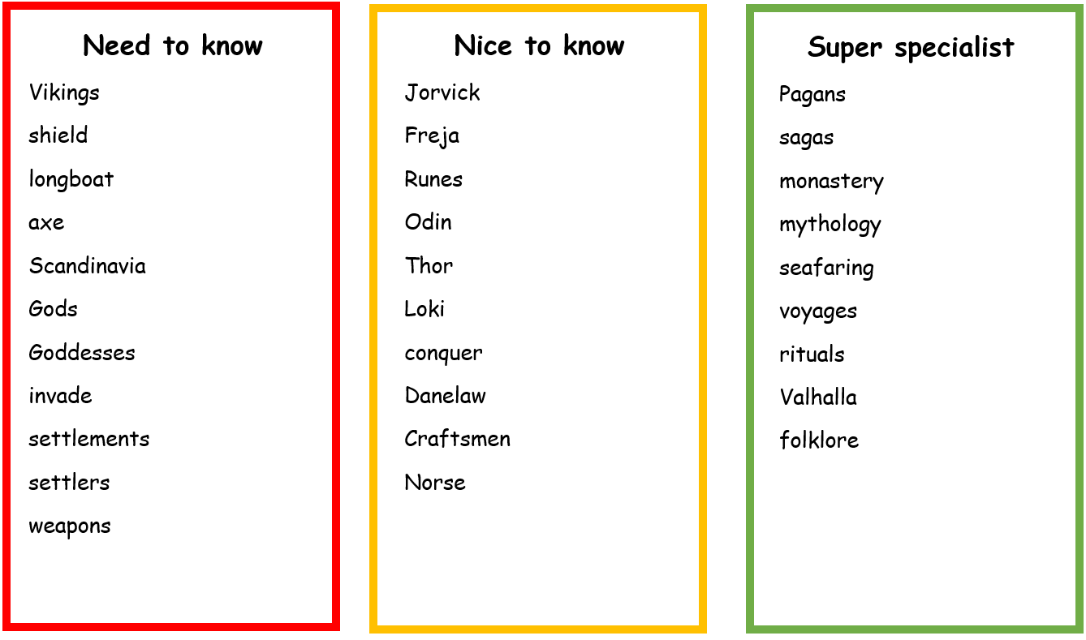

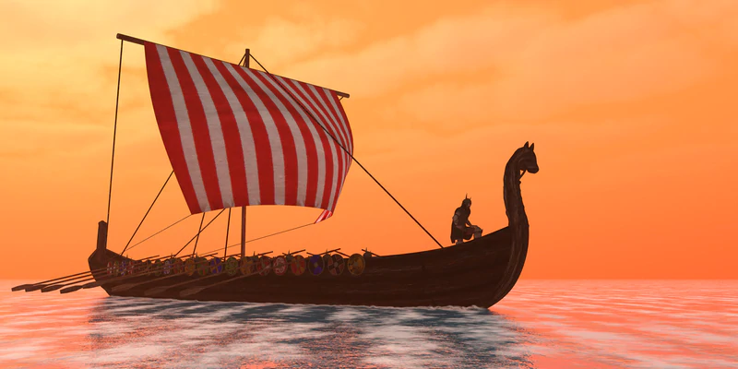

Links to Prior Learning | Key Texts | Links to Future Learning
- Knowledge of past, present and future.  - Chronology skills and ordering events.  - Knowledge of the Roman invasion.  - Knowledge of Gods and Goddesses.  - Comparison skills.  - Ability to locate on a map.  - Knowledge of weaponry from Stone age to Iron age topic. | - Arthur and the Golden Rope - Joe Todd Stanton.  - The Last Viking - Terry Deary  - The Vikings: Raiders, Traders and Adventurers! - Marcia Williams  - There's a Viking in My Bed and Other Stories - Jeremy Strong | - Comparison skills.  - Anglo-Saxons  - Battle of Hastings  - King Alfred the Great
Family Fun
- Make your own Viking trollen wheel used for braiding yarn.
- Follow Viking recipes to make some delicious food fit for a warrior!
- Practice your runes writing to create your name and a secret message.
- Watch the compilation video about the Vicious Vikings: https://www.youtube.com/watch?v=IDzGv2mEazs
