Monday 6th December 2021
LO: To know what Christingle symbolises for Christians.
P | I can | CT
 | I can explain when Christians celebrate Christingle.
 | I can name what each part of the Christingle symbolises.
 | I can create my own Christingle.

What does each of the key features of the Christingle mean?
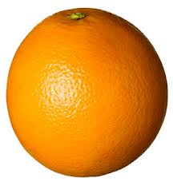
The orange reminds us of
___________________________________________________________


The ribbon reminds us of
____________________________________________________________

The sweets remind us of
____________________________________________________________

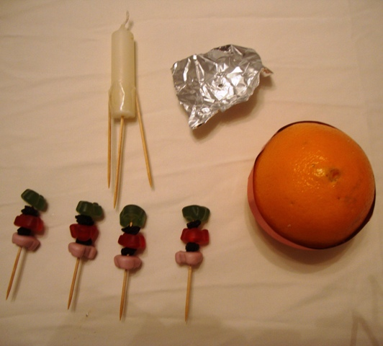
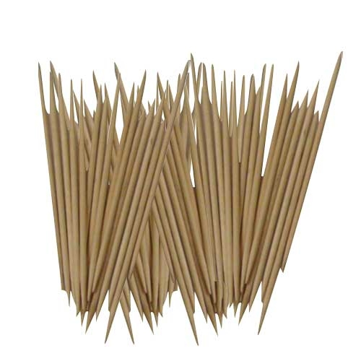

The sticks remind us
___________________________________________________________

The candle reminds us
___________________________________________________________

