
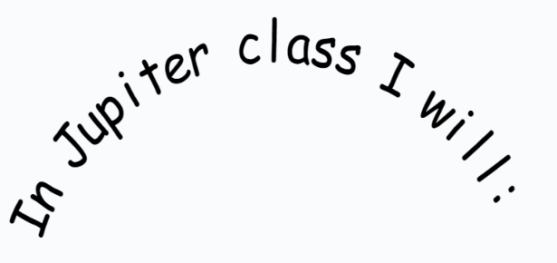
Some of our class rules are:
- Don’t shout out or interrupt each other.
- Always support each other.
- Keep a safe distance from adults.
I will always have fun with my learning.

I will always have a positive attitude and focus on a growth mindset.
I will always try my hardest, especially when I am finding something tricky.
I will always work with others and share ideas.

