PSHE  LO: To be aware of the factors which influence their food choices.  Work through the PowerPoint to complete the discussions and activities.  Watch three different adverts for food e.g. cereal, chocolate bars, yogurt. Fill in the food advert sheet, tell us if you think the advert is persuasive and give reasons.  What makes the advert effective? | PE    Complete a Joe Wicks 30 minute workout.
RE  LO: To recognise the main symbol associated with Islam.  Work through the PowerPoint to understand more about the symbols associated with Islam. Can you name any of the symbols for the other main religions?  Create a hanging mobile to show the main symbol associated with Islam. Can you design your own Islamic symbol to add to your mobile. Explain why this links to Islam. | Coding  Using espresso coding, complete the espresso Block Coding Level 3 lesson –Space Maze. The videos will explain how to complete each task.  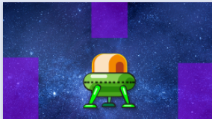  Your child should be able to follow this with minimal support.

Bonus
Can you go on a Summer Scavenger Hunt. Using the sheet attached, how many Summer treasures can you find?


Oak/Jupiter Class Home Learning Week Commencing 7th June 2021

