
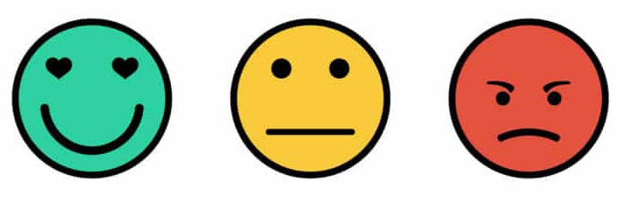
NEXT STEP
Self-Assessment:

How do you feel about your artwork?
(circle the face you feel)

I could improve by:
________________________________________________________________________________________________________________________________________

