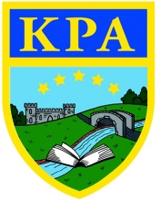
Puddleducks Home Learning Rainbow Challenge
Communication and Language  Why?  Here are some questions to ask you children to help develop the understang of why? Questions.  These are only ideas, you can adapt them to engage your childs personal interests!  Do you prefer Spiderman or Superman? Why?  Would you rather eat carrots or cabbage? Why?  Do you prefer pasta or pizza? Why?  If you could fly, what would you do? Why?  Do you prefer dogs or cats? Why? | 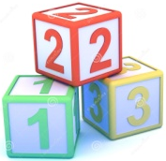  Home learning w/c 4th January 2020.  Here are some challenges to get you  started this year!  Please let us know how you are getting on either by putting what you have been doing on your child’s Tapestry or emailing me at puddleducks.kimbolton@gmail.com  We hope you are all well and hope to see you soon. | Physical Development  Can you complete these exercises?  Touch your toes 5 times.  10 Star jumps.  Stretch up to the sky 10 times.  Stand on one foot.  Do 5 push ups (on hands and knees)  Can you think of any other exercises you could do?  Aim – Move in a range of ways, keep our bodies healthy.
 | Understanding the World  As part of our wild challenge award we are completing we have a set of challenges to complete.  One of these challenges is to make a musical instrument with things you find in the natural world. This could be sticks to tap together or tapping a rock on a tree. Use your imagination! | Expressive arts and design  Sing or listen to a song you like. Can you make up a simple dance to it?  Could you dress up?  Aim – To use movements to music and sing simple songs and rhymes.  Don’t forget to take a photo or video for Tapestry!
Personal, social and emotional
Ask you child/ren make a thank you card for something they recieved for Christmas.
Talk about how they felt when they opened the gift and what they like most about it.
Talk about how people feel when they give and recieve gifts.
Aim – To recognise different emotions.
Mathematics
Number Hunt.
Ask your child if they can find a certain amount of objects. For example,
“Can you find me 3 leaves?”
“Can you find 6 things that are red?”
Aim – Find the correct amount of objects when asked.

Literacy
Read a story with your child. Talk to your child about the pictures, can the name the characters? Can they point to objects? What do they think might happen next? Did they like the story? Why?
Aim – Listen to stories with increasing attention and recall, talk about characters and illustrations. Develop an enjoyment of books and pictures.

