ROWAN CLASS -TRADITIONAL NOTATION

In music we already know that each note has a name: A, B, C, D, E, F, G. Each group of notes is called an octave. After note G we go back to A, B, etc. We plot each note on its own line or space on the stave/staff.

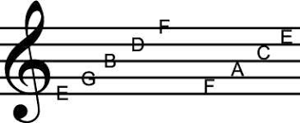

How many words can you make using only these notes, ie dad, cabbage. What is the longest word you can make?

Each stave is made of 5 lines and 4 spaces and we always count up from the bottom line. At the beginning of each stave is a treble clef 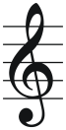.

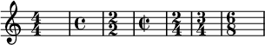
You will also find the time signature which will tell you how many beats are in a bar.

Sometimes you will also find that there are other symbols written after the time signature. These are incidentals and will indicate whether a note should be played flat (half a tone below) or sharp (half a tone above). You may recognize these notes as the black keys on a piano or keyboard. Flats are indicated by a symbol a bit like a lower case b and the sharp by a symbol like a hash tag.

Notes can also be different lengths – crotchets 1 beat, quavers half beats, semiquavers quarter beats

You can create melodies by placing the notes on the stave and make them more interesting by using quavers and semiquavers. You could also use rests to add dimension. Also, think about dynamics (volume), tempo (speed),
 = crotchet rest, 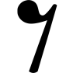= quaver rest

Using this information, place each note on the stave to create a melody you can play in class. You could use the words you found above to help. Either print off the music manuscript or draw groups of 5 lines.
Name: _________________________________________ Date: ______________________

Title of Music: ______________________________________________________________

