PE Kit
Please make sure your child has their PE kit in school at all times. Make sure all items are clearly labelled and are in a suitable bag.
Indoor PE Kit: Children need a blue t-shirt with the KPA logo, navy shorts and black pumps.
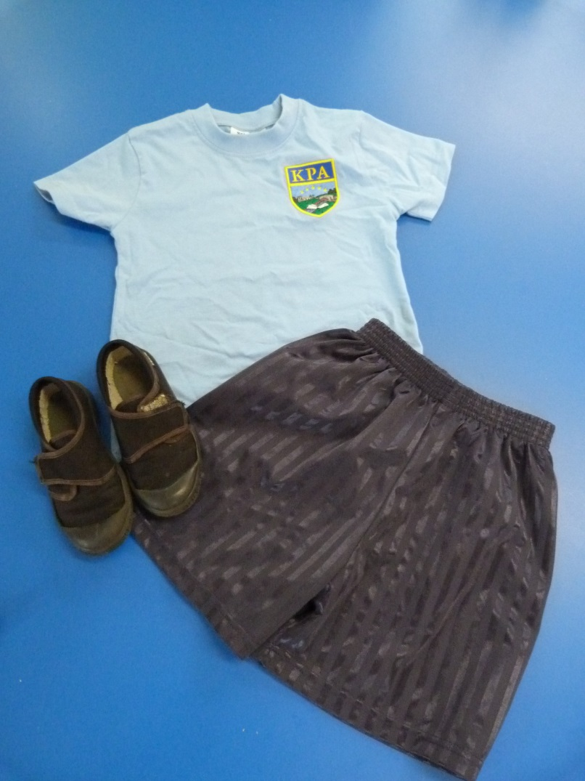

Outdoor PE Kit: (Oak and Rowan): Weather permitting children will be having some of their lessons outside so children need a plain navy pair of tracksuit bottoms, a navy sweatshirt and trainers alongside their indoor PE kit.
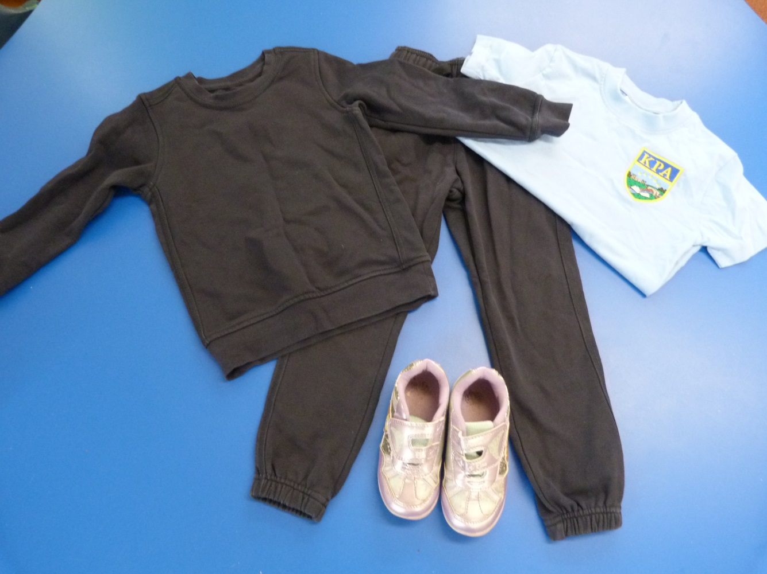
Please make sure your child brings their kit in as soon as possible and please make sure that it stays in school.

