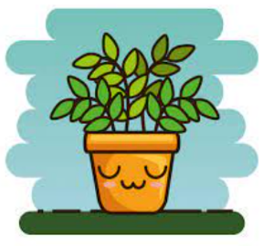
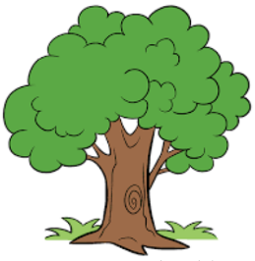
Plants KWHL

What I know | What I want to know | How I’ll find out | What I found out

