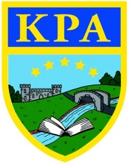
Puddleducks Home Learning Rainbow Challenge
Communication and Language  Sing a song.  Sing nursery rhymes or favourite songs with your child!  You could make your own band and sing along.  Could you make up a dance or actions to the song.  Aim – Develop a wide vocabulary, work together. | 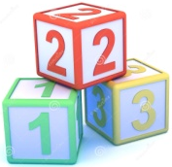  Hello everyone!  We hope you had a peaceful half term.  Here are some challenges for you to get stuck  into this week!  Please let us know how you have been getting on, we love to see what you have all been up to!  Mandy and Lisa. | Physical Development  Build a Obstacle Course.  Use things from around your home and garden to create an obstacle course for your child.  You could:  Jump over a rope.  Walk along a tea towel or line of tape on the floor.  Roll a ball to hit a target.  Crawl under a table/chair.  Be as creative as you want!  See who can complete your course the fastest.  Aim – Move in a range of ways, develop gross motor skills.
 | Understanding the World  Natural Printing.  Either when you are out for a walk or from your garden collect different shape flowers and leaves to use for printing!  Put a little paint on a plate or tray and let your child be creative!  Aim: Notice and talk about the world around us, and show care and concern for living things. Comments and asks questions about the natural world. | Expressive arts and design  Junk modelling.  Give your child a selection of boxes etc from your recycling. What can they build with them. Talk about what they will need to join/cut there recycling with. Has their idea worked?  Aim: Use a range of materials and tools to build with using our imaginations.
Personal, social and emotional
Play a game or complete a puzzle with another person.
Talk about who’s go it is next, why is it nice to take turns?
Aim – Share and take turns.
Build positive relationships with others.
Mathematics
Find the heaviest.
You can do this with any objects, just ask your child to choose 2 objects from around the house or garden. Then tell you which one is the heaviest!
Can they find something heavier?
Can they order 3 objects from lightest to heaviest?
Aim – Order items by weight!
Literacy
Mark your name.
Encourage your child to practice writing the letters of their name. Talk about the shapes of the letter and model how to write it correctly.
Also – Don’t forget to keep reading!
Aim – Be able to mark own name.

