22nd November 2021
Task: Continue the story about the polar bears.

Capital letters &  Full Stops  A • |   Connectives | WOW  words | Careful  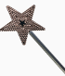  spelling | 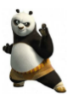  Kung fu punctuation | My writing makes sense.

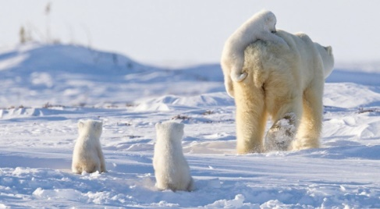

There was only one thing on her mind. Survival.
With one of her cubs clinging on to the soft, comfortable fur on her back and the other two not far behind, she set off across the snow. She was their protector, their teacher, their guide and their provider of food. The weight of the task ahead weighed heavily on her powerful shoulders.
This was not the first time she had made this journey. She could remember walking this very same path with her mother, many years ago. Now, the circle of life had turned, and it was her time to be the responsible one.
Her cubs, only a few weeks old, seemed so vulnerable out here, so tiny beside her massive frame. They were also beautiful; their fur almost as white as the snow that surrounded them, their curious, wet-nosed faces looked around in awe of the world they had been born into. They meant everything to her, and she would do anything to keep them safe. They, in turn, would rely upon her love for them over the harsh winter.
She gave a gentle grunt, urging her cubs to keep up. They had to stick together…

________________________________________________________________________________________________________________________________________________________________________________________________________________________________________________________________________________________________________________________________________________________________________________________________________________________________________________________________________________________________________________________________________________________________________________________________________________________________________________________________________________________________________________________________________________________________________________________________________________________________________________________________________________________________________________________________________________________________________________________________________________________________________________________________________________________________________________________________________________________________________________________________________________________________________________
___________________________________________________________________________________________________________________________________________________________________________________________________________________________________________________________________________________________________________________________________________________________________________________________________________________________________________________________________________________________________________________________________________________________________________________________________________________________________________________________________________________________________
_______________________________________________________________________________________________________________________________________________________________________________________________________________________________________________________________________________________________________________________________________________________________________________________

