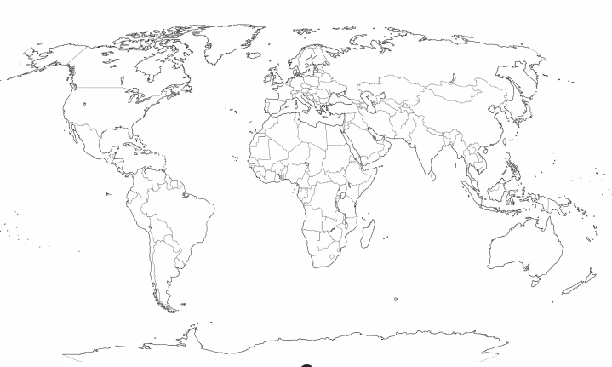
L.O: To identify the location of hot and cold countries. w/c 11th January 2020
Asia
Africa
North America
South America
Antarctica
Europe
Australia

Task:
Can you draw the equator on the map? Remember to use a ruler.
Can you label the 7 continents?
Can you find and label a hot and a cold country? Colour a hot country red and a cold country blue.

