- Count in 10s from 0. Colour all the numbers yellow.
- Count in 5s from 0. Colour all the numbers red.
- Count in 2s from 0. Colour all the numbers blue.
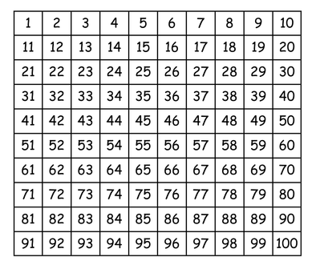
What patterns do you notice?

