Cut and stick the picture into the correct order to sequence the story.

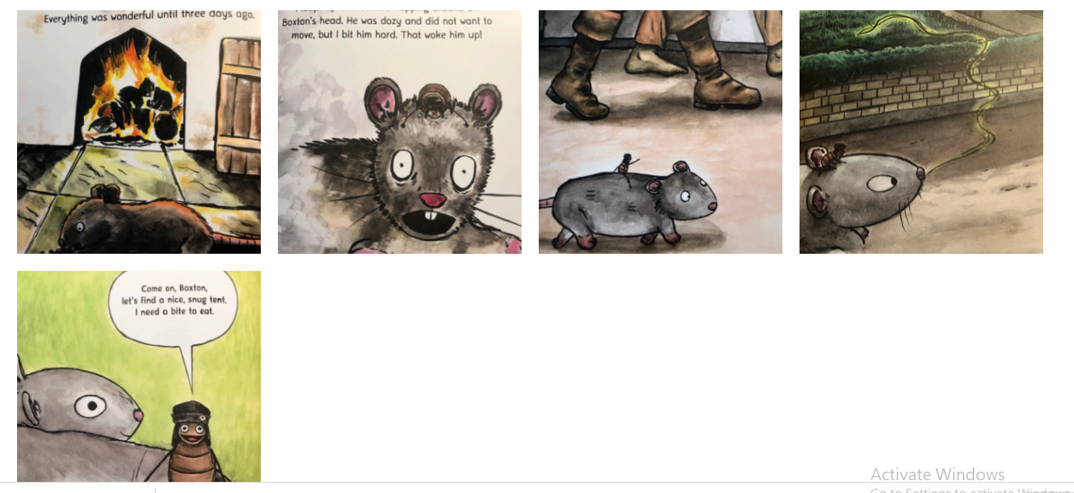

1 | 2 | 3
4 | 5
Date: 27th September 2021
LO: to sequence the events in the story.
P | I can | CT
 | Must: identify the key events in the story.
 | Should: sequence the key events.
 | Could: consider how the characters were feeling at different points in the story.

Sequence the main events in the story. Challenge: add time connectives to help sequence the events.

