Build the array with counters.
Complete the sentences.

There are ____ apples in each row.
There are ____ rows.
____+____+____=____
There are ____ apples altogether.
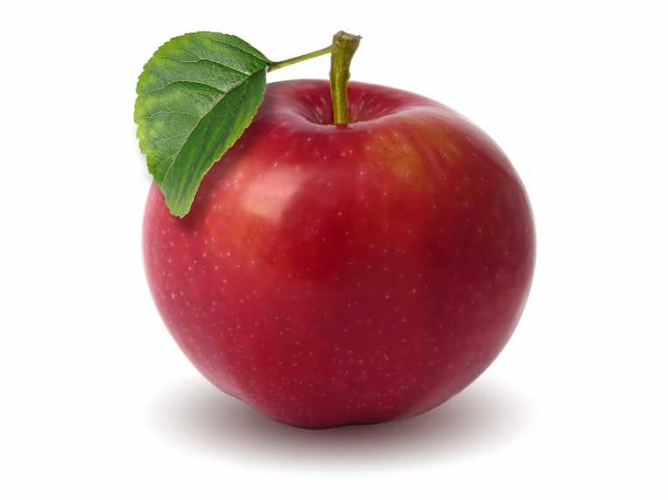
Build the array with counters.
Complete the sentences.

There are ____ apples in each row.
There are ____ rows.
____+____+____=____
There are ____ apples altogether.
Build the array with counters.
Complete the sentences.

There are ____ apples in each row.
There are ____ rows.
____+____+____=____
There are ____ apples altogether.

Build the array with counters.
Complete the sentences.

There are ____ apples in each row.
There are ____ rows.
____+____+____+____=
There are ____ apples altogether.

Build the array with counters.
Complete the sentences.

There are ____ apples in each row.
There are ____ rows.
____+____+____+____+____
There are ____ apples altogether.
Build the array with counters.
Complete the sentences.

There are ____ apples in each row.
There are ____ rows.
__+__+__+__+__+__=
There are ____ apples altogether.
Build the array with counters.
Complete the sentences.

There are ____ apples in each row.
There are ____ rows.
____+____+____+____+____
There are ____ apples altogether.
Build the array with counters.
Complete the sentences.

There are ____ apples in each row.
There are ____ rows.
____+____+____+____
There are ____ apples altogether.

