
I have 3 pencils in my pot. It fits 20.
How many more can fit in the pot?

There are 20 buttons on my coat.
I have fastened 2, how many more
are there to do?

Tom has 6 apples in a bag. The bag can hold 20.
How many more apples can fit in the bag?

I have a bag with one sweet in.
The bag can fit 20 sweets.
How many more sweets can it fit?

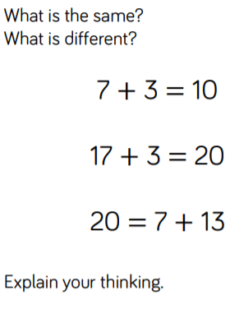
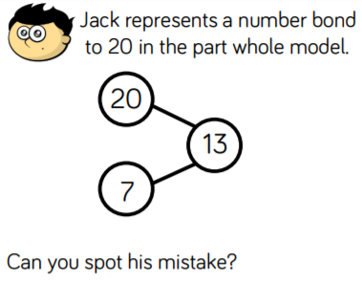
O
O
O
O

TO
TO
TO
TO
TO

