Date: 28th September 2021
LO: to plan my diary
P | I can | CT
 | Must: sequence key events.
 | Should: record key vocab
 | Could: record feeling words eg scared.

Record what happens in each picture. Can you add key words, feelings and time connectives?

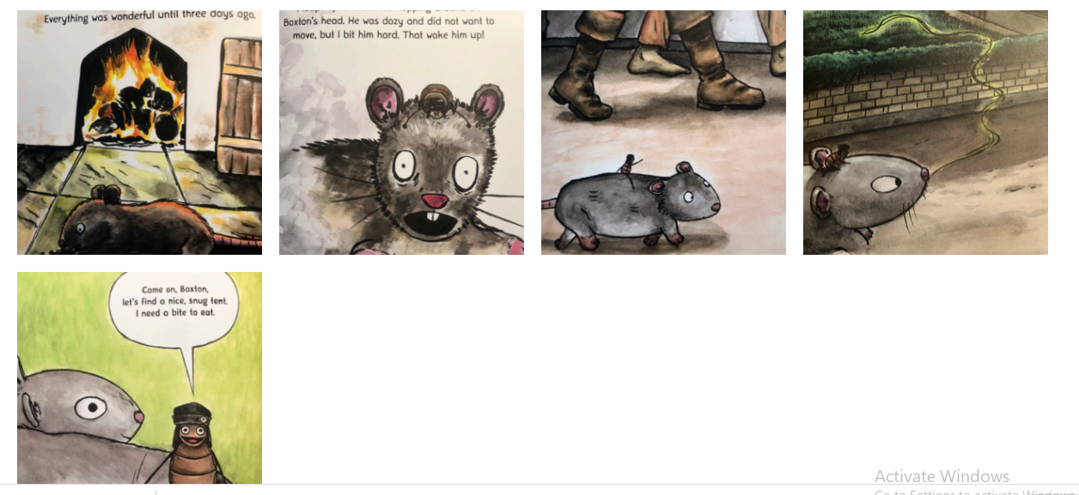 | First we found a nice cosy spot to sleep for the night.
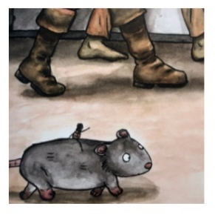 | I was worried we might be squashed in the streets. Lots of people were running away!
