27. 04.21
LO: To count forwards and backwards in 5s.
P | I can | CT
 | Must: count in multiples of 5 from 0-100.
 | Should: count objects in groups of five and find 5 more and 5 less.
 | Could: problem solve and reason.

Count in 5s to find the total number of objects.

5 | 10 | 15 | 20 | 25 | 30

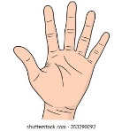
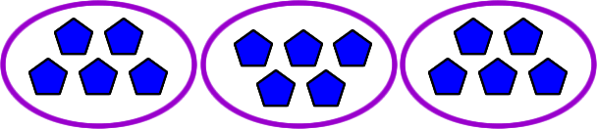
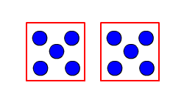
Draw 4 groups of 5

