Numberbonds
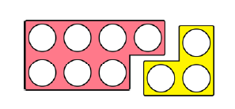
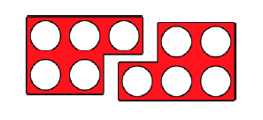
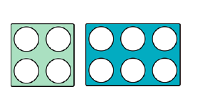
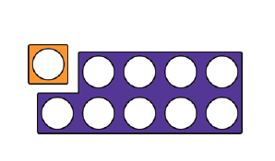
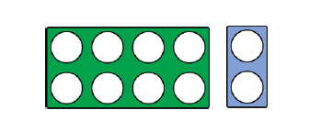
3 + __ =
7 + __ =
5 + __ =
5 + __ =
4 + __ =
6 + __ =
1 + __ =
9 + __ =
8 + __ =
2 + __ =

