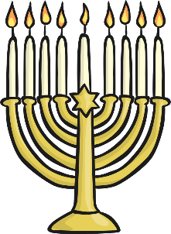  ____________________________________________________________________________________________________________________________________ | 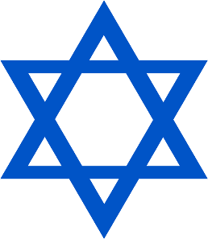  _  ____________________________________________________________________________________________________________________________________
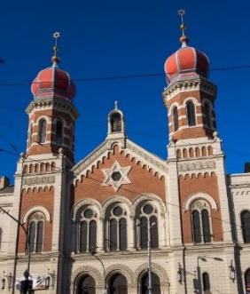  ____________________________________________________________________________________________________________________________________ | 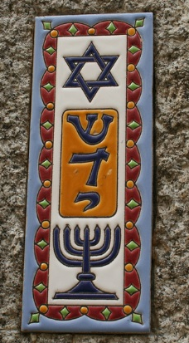  ____________________________________________________________________________________________________________________________________
LO: To understand the meaning of some Jewish symbols.
Star of David mezuzah
Worship important
Hanukah menorah Judaism
Festival
Synagogue Rabbi service

Something easier: Cut out and words to help you label the pictures by sticking the correct word under the correct symbol.

Star of David | mezuzah
menorah | Synagogue

