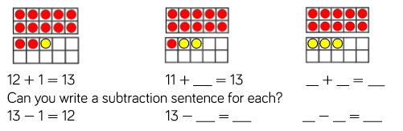
Write the related number facts for each picture. Can you find them all?

