Homework: Thurs 22nd September due Tuesday 28th Sept 2021

We have been working hard to recognise and write b and d as we keep mixing them up! Complete the activities below to practise! Remember: ‘d’ starts with a ‘c’ shape. ‘b’ starts at the very top, back up half way and then round.

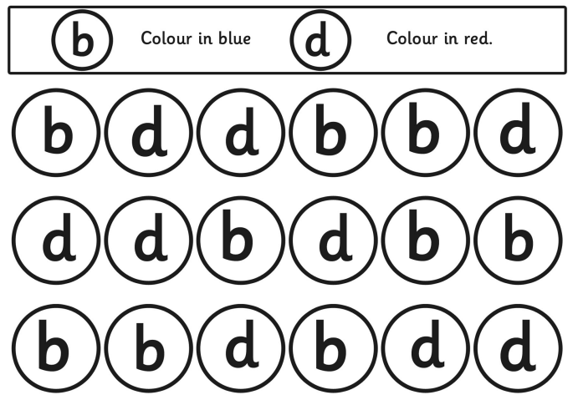

Write down 3 words beginning with b.

Write down 3 words beginning with d.

Can you use your words in a sentence?
________________________________________________________________________________________________________________________________________________________________________

