Homework Due Tuesday 5th October 2021
Thursday 7th October is National Poetry Day. We will be celebrating by holding a mini poetry slam! Please choose a poem from the selection to recite. Learn if off by heart if you can! You may choose to learn a line at a time over the week.
Top tips for performing:
- Use a nice big voice.
- Look at your audience
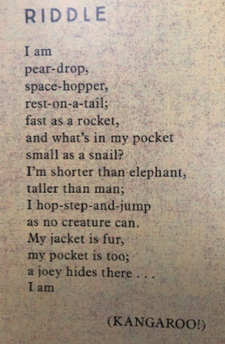
- Recite your poem with expression
- Smile!
