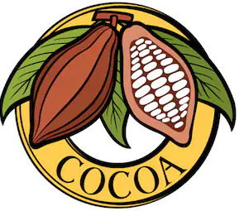
Bean to Bar: Chocolate!
What you know | What you want to know | What you found out
 |  | 